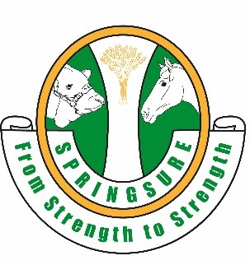
SPRINGSURE SHOW SOCIETY
SECTION 6 – CATTLE DOG TRIALS
STEWARDS: Mr David O'Connor PH: 49841 966 / 0488419666
ASSISTANT STEWARD: Mrs Adele O’Connor PH: 49841966/0429300182

15th and 16th June 2024 at the Springsure Showgrounds.
Please contact Stewards listed above for further information.

Regulations

- Nominations (by phone) to the Stewards listed above.
- All entries to the Steward so that cattle can be organised.
- Open and Novice sections will be run as two rounds each.
- Stockman Handler will be one round and is for those willing to have a go and have fun.
- Points will be collected for Queensland Working Cattle Dog Association.
- Entry fees to be paid into Show Society Bank Account
BSB: 813 049 ACC 100092917 REF Dog Trials + Name
- For further details and conditions please contact the Steward

Class |  | Open Entry Fee $15
Class |  | Novice Entry Fee $12
Class |  | Stockman Handler Entry Fee $5

