SPRINGSURE SHOW SOCIETY
SECTION 4A GOATS
Friday 31st May - Saturday 1st June

- Entries Close – 3rd May 2024
- Nomination Fees - $5 per Goat (Substitute animals are allowed but must be for same class)
- Delivery of Goats – Thursday 30th May 2024
- Judging – Meat Goats – Friday 31st May 2024
- Judge: TBA
- Stewards: Glenda Henry 0428 774 687 Kylie Leahy 0437 881 246
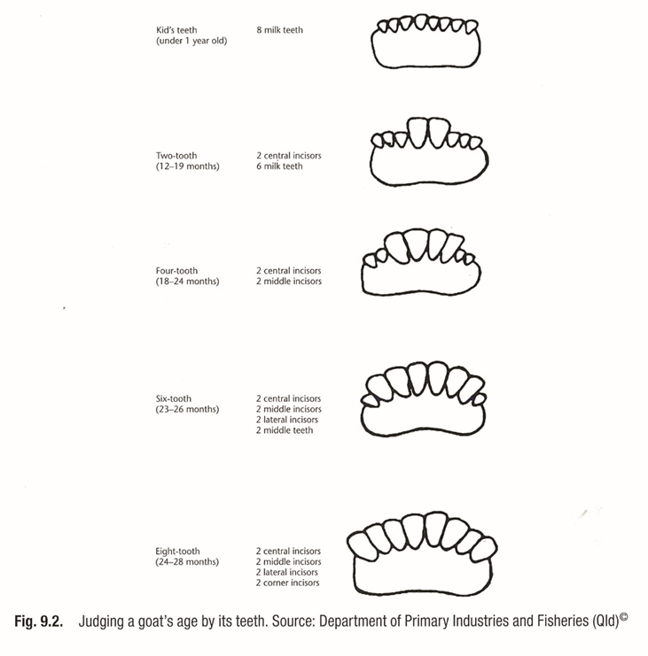
- Limited camping sites @ $10 will be available onsite. Stewards will be in attendance overnight to monitor goats kept onsite.
- For this Show, all Meat Goats will be judged on their individual attributes combining Stud & Commercial animals in each class.
- Standard Goat is regarded as any goat that has predominately Coloured head with White body.
- Coloured Goat is red, black or predominately mixed coloured.
- Mouthing will be done on site using the attached DAFF chart.
- Springsure Showgrounds PIC QIBH2006.
Conditions of Showing
- General regulations as per Springsure Show rules.
- Classes are open to all Goats. This Show is to
promote the Meat Goat industry. Any commercial or breed association member is welcomed.
- Animals must be free of external parasites/lice & must not have any bald or open abscesses. Inspection on arrival.
- Class will be as mouthed on the day of Show, 31st May 2024.
- Casual tidy attire with closed in shoes is required. Springsure can get very cold/hot, please bring a jacket & hat. This is an open-air event so please be sun safe.
- Classes may be altered depending on numbers of entries. Any alteration will go up a class or class may be cancelled.
- All goats will require a collar or head collar.
- Kids shown on Does cannot compete in the mouthed classes.
- Welfare, feed and watering of all animals is the responsibility of the entrant.
- Entry forms, Animal Health Declarations, receipts of payments emailed to qldgoatgroup@gmail.com, spaas1865@gmail.com
- Bank details for nomination fees: BSB: 813 049 ACC 100092917 REF Section 4 A Goat

Class 1 – Standard Doe Milk Tooth
Class 2 – Standard Doe 2 tooth
Class 3 – Standard Doe 4 tooth
Ridley Ag Junior Champion & Reserve Standard Doe
Class 4 – Standard Doe 6 tooth
Class 5 – Standard Doe 8 tooth
Class 6 - Standard Doe Full Mouth +
Senior Champion & Reserve Standard Doe
Class 7– Standard Buck Milk Tooth
Class 8 – Standard Buck 2 tooth
Class 9 – Standard Buck 4 tooth
Junior Champion & Reserve Standard Buck
Class 10 – Standard Buck 6 tooth
Class 11– Standard Buck 8 tooth
Class 12 - Standard Buck Full Mouth +
Thursby Welding Senior Champion & Reserve Standard Buck
Class 13 – Coloured Doe Milk Tooth
Class 14 – Coloured Doe 2 tooth
Class 15 – Coloured Doe 4 tooth
Junior Champion & Reserve Coloured Doe
Class 16 – Coloured Doe 6 tooth
Class 17 – Coloured Doe 8 tooth
Class 18 - Coloured Doe Full mouth +
Senior Champion & Reserve Coloured Doe
Class 19– Coloured Buck Milk Tooth
Class 20 – Coloured Buck 2 tooth
Class 21 – Coloured Buck 4 tooth
Junior Champion & Reserve Coloured Buck
Class 22 - Coloured Buck 6 tooth
Class 23 - Coloured Buck 8 tooth
Class 24 - Coloured Buck Full Mouth +
- C&K Macnab Concreting Senior Champion & Reserve Coloured Buck
- Coolamon Mining Grand Champion Doe
- Grand Champion Buck
- Coolamon Mining Supreme Champion Exhibit in Show
Group Classes
Class 25 – Sires’ Progeny – 3 animals, any sex or age that have been exhibited in other classes.
Class 26 – Breeders’ Group – 3 animals, any sex, any age, bred & owned by the exhibitor & have been exhibited in other classes.
Meat & Livestock Aus. Meat Wether (potential carcass) milk tooth
Class 27 - Under 25kg milk tooth
Class 28 - Under 40kg milk tooth
Class 29 - 40kg > Milk Tooth
- MLA Champion Wether
- Champion Exhibitor (Most Points at Show)

