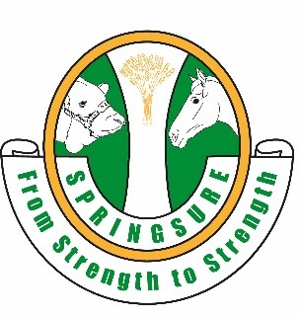
SPRINGSURE SHOW SOCIETY
SECTION 1B Invitational Brumby Challenge
Saturday 1st June 2024
8:00am
Nomination $20.
Steward: Rachel Pierce 0417015257
EMAIL: horses@springsureshow.com.au
Rules for Brumby Challenge.
- Competitors under the age of 18 must wear a helmet.
- Judge’s decision is final.
- All competitors compete at their own risk and must sign a waiver.
- Nominations must be received by Monday 20th May 2024 and PAID IN FULL by Friday 31st May, 2024. Nomination Forms and Healthy Horse Forms to be emailed to horses@springsureshow.com.au by 20th May 2024.
- Scratchings will be accepted up until 3 days before the Show or with a vet certificate, otherwise money will be forfeited.
- A brumby can be entered in Class 1 or Class 2 only, NOT BOTH.
- Points from each phase will be combined to award 1st to 6th in each class. No ribbons/prizes will be awarded for individual phases.
- Each phase will be completed by all ridden competitors and then the same phase will be completed by led competitors, before moving onto the next phase.
- Freestyle routines are to be no longer than TWO minutes. A bell/whistle will sound with 30 seconds remaining and a second at conclusion. Set up time is to be no more than four minutes.

Class 1. Ridden Brumby
- Connection
- Pattern
- Obstacle Course
- Freestyle
Class 2. Led Brumby
- Connection
- Pattern
- Obstacle Course
- Freestyle

