Springsure P & A (Show) Society INC.
EST 1865

Sponsorship Invitation
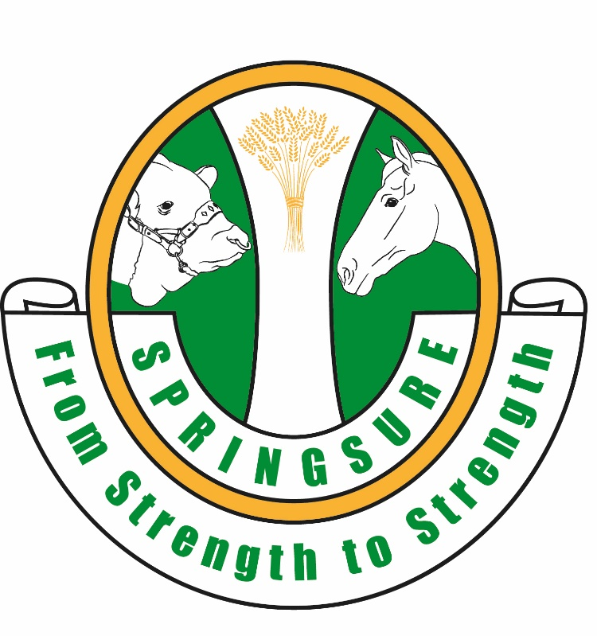

Springsure P & A (Show) Society
PO Box 59, Springsure 4722 QLD

Email: sponsorships@springsureshow.com.au
Phone: 0427088797
Website: www.springsureshow.com

President: Mrs Joyce Comiskey Secretary Ms Chantelle Lang Sponsorship: Mrs Sarah Bridgeman
Treasurer: Mrs Jaclyn King

SPRINGSURE P & A (Show) Society
friday 31st May and Saturday 1st JUNE 2024
Sponsorship confirmation
If you would like to sponsor the 2024 Springsure Show, please complete this form and return via post, email or text message. Once your form is received by our treasurer, she will email you a tax invoice.
Email: sponsorships@springsureshow.com.au
Bank details: BSB: 813 049 ACC: 100092917
Post: PO Box 59, Springsure Qld 4722 Text message: Jaclyn King 0427 749 774
- For inclusion in the 2024 Schedule and Show Advertising, please ensure this form is returned by 25th February 2024
- Please email your logo and/or advertisement in JPEG format to sponsorships@springsureshow.com.au
- Sponsors are responsible for supplying banners/signage. We can arrange pick up or delivery.

PLEASE TICK THE APPROPRIATE BOXES BELOW:

I would like to sponsor the Springsure Show to the value of $_____________or Sponsorship Package Level _________________ (refer to Sponsorship Benefits Page at end)

I would like to sponsor a specific area of the Springsure Show (please indicate)
- □ Pavilion
- □ Horse Events – Dressage, Show Jumping etc
- □ Stockman’s Challenge
- □ Stud Cattle Section
- □ Poultry Section
- □ Dairy/Meat Goats Section
- □ Woodchopping
- □ Dog Trials
- □ Brumby Challenge (new feature event)
- □ Entertainment
- □ Prime Cattle (seasons permitting)
- □ Show Girl / Rural Ambassador
- □ Other _________________________

A free trade site is part of our sponsorship package and we are interested in taking up this option.

We are not interested in sponsoring your 2024 Show.

Sponsor Contact Details

Contact Name: _______________________________________________________________
Business Name: ______________________________________________________________
ABN: _______________________________________________________________________
Address: ____________________________________________________________________
Phone: _____________________________ Mobile: _________________________________
Email: ______________________________________________________________________
Sponsor Benefits
Sponsor Benefits | Tri Colour  $2000 | Blue Ribbon  $1000 - $2000 | Red Ribbon  $500 - $999 | White Ribbon  $200 - $499
Admission Tickets | Yes x 4 | Yes x 3 | Yes x2 | Yes x 2
Official Opening Acknowledgement | Yes | Yes | Yes | Yes
Trade site (Limited size) | Yes (10 x 6m) | Yes (6 x 6m) | Yes (6 x 3m) | Yes (3x3m)
Presentation Rights | Yes | Yes | Yes | Yes
Public Address Acknowledgments (Show Announcer) | Yes | Yes | Yes | Yes
Show Girl /Rural Ambassador Dinner or event tickets | Yes (4) | Yes (3) | Yes (2) | Yes (2)
Signage (Banner on display) | Yes | Yes | Yes | Yes

