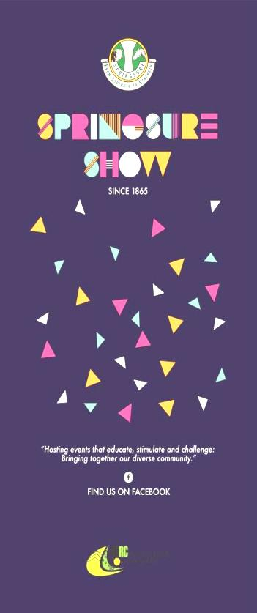
Show News – march 2021
SAVE THE DATE!
Friday 28th May and Saturday 29th May 2021.
Check out the new signs upon entry to Springsure. Thank you to 1800 Prints for the supply of the new advertising signs for our show.

Sponsors
Thank you to all our new and continuing sponsors for your support of our annual show. Your support is greatly appreciated. If you would like to sponsor the show in any way, please contact us via email to request a sponsorship package. Please email Sarah springsureshow1865@outlook.com

Membership
Forms are available from our website, the Springsure Library, Rolleston Transaction Centre and our website or by emailing the email addresses at the end of this newsletter.
Membership fees are due by 30th April 2021

2021 Schedule
The schedule to be used for this year will be available free of charge from early March. Changes to the booklets with regards to dates and information will be attached to the inside cover. If you have any questions regarding a section, please contact the relevant steward for that section. Or alternatively, you can contact us on one of the emails at the end of this newsletter.
Schedules will be available from Springsure Newsagency, Mitre 10, Rolleston Transaction Centre, and Eclipse Street Emporium.
Springsure and Rolleston Libraries will have electronic copies of our schedule – the library assistants will print off sections of the schedule you are interested in for a small fee. The schedule, as well as entry forms will also be available on the website.

Pavilion News
Don’t forget the new sections in the pavilion this year!!
HIGH TEA FOR TWO
Imagine you are at The Customs House in Brisbane or at The Stamford Plaza and High Tea is served! What comes to mind? Cucumber ribbons sandwiches, petite cream filled delicacies, bite sized pieces of slice and beautifully displayed on pretty plates on a tray, complete with China teacups and teapot.
This is a new category in the pavilion this year. Look out for it in the cookery section 11 Class 1151

The pavilion sections are looking for volunteers and sponsorship. If you are interested in sponsoring an area in the pavilion or assisting in some way, please contact the Chief Pavilion Steward, Mrs Jo McNamara. Sponsorship amounts for the sections are $30.

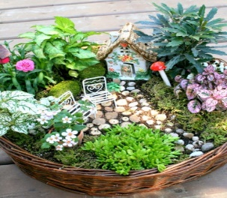
AND THE FAIRY GARDENS
We have heard a whisper around town that there are a few fairy gardens about. We would like to invite you to create a small fairy or elves garden on a tea tray or in a container (max size 500mm x 300mm) to display in the pavilion. There will be no entry fee and therefore no prize money for these. Ribbons will be awarded.

Giant Pumpkin Competition – Don’t forget your seeds. Seeds available from Springsure Newsagency – 3 seeds for $5

Look for the new competition details in this bulletin. Here is a hint.

Website: www.springsureshow.com
Facebook: www.facebook.com/springsureshow
President: Mrs Christine Rolfe
Show Secretary: Mrs Leanne Jones Email: spaas1865@gmail.com
Minute Secretary/ Sponsorship Coordinator: Mrs Sarah Bridgeman Email: springsureshow1865@outlook.com
Treasurer: Mrs Jaclyn King Email: spaas1865treasurer@gmail.com

