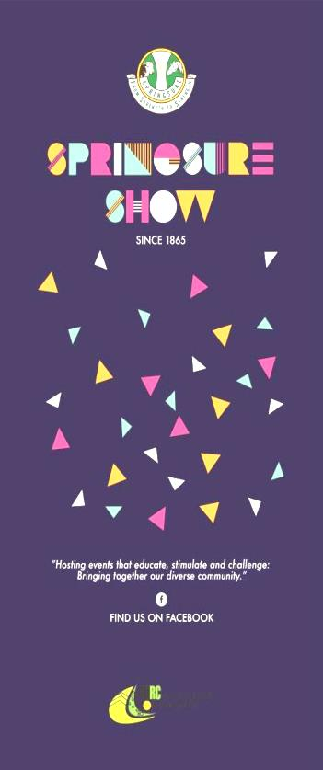
Show News – February 2021
With fingers and toes crossed, the 2021 Show will go ahead on Friday 28th May and Saturday 29th May 2021. At this stage, planning for the show is going ahead as normal with a COVID Safe Plan devised by Queensland Ag Shows for all agricultural shows in Queensland to use.
Thankfully we have had some great rainfall over the last month and if we are lucky enough to receive some more, it should set us up for a great show.
Sponsors
Thank you to all our new and continuing sponsors for your support of our annual show. Your support is greatly appreciated, and you will be publicly acknowledged during our show advertising. If you would like to sponsor the show in any way, please contact us via email to request a sponsorship package. Please email springsureshow1865@outlook.com With the use of banners, public address systems, social media advertising, promotional material and flyers, you won’t find a better way to advertise your business in our local community.

Entertainment
A huge thank you to Glencore Rolleston Coal, SOJITZ Minerva Mine, SANTOS, and Origin for the continued support of our show. They have once again provided the funds for the fireworks and entertainment at the show.

Membership
Thank you to the continuing members who paid membership in 2020. Your continued support is appreciated.
Membership forms will be emailed to all previous members in near future. If you would like to become a member, you will receive these benefits: free entry to the show, discounted entry fees in the pavilion and a lucky member will have their name drawn out each day of the show for a prize. More benefits are listed on the membership form.
Forms will also be available from our website, the Springsure Library, Mitre 10, Rolleston Transaction Centre and our website or by emailing springsureshow1865@outlook.com.
Membership fees are due by 30th April 2021

2021 Schedule
The 2020 Schedule be reused this year as it was printed for last year but not used. Changes to the booklets with regards to dates and information.
Schedules will be available for purchase by mid to late February from Springsure Newsagency, Mitre 10, Rolleston Transaction Centre, and Eclipse Street Emporium (gold coin donation)
Springsure and Rolleston Libraries will have electronic copies of our schedule – the library assistants will print off sections of the schedule you are interested in for a small fee.
The schedule, as well as entry forms will also be available on the website.

Pavilion News
The pavilion sections are looking for sponsorship. If you are interested in sponsoring an area in the pavilion, please contact the Chief Pavilion Steward, Mrs Jo McNamara. Sponsorship amounts for the sections are $30.
We are excited to back for the 2021 show. Although last year we were able to do a few show competitions online, we are very eager to see what everyone has been up to since our last show in 2019. We are hoping that everyone has been really busy and have a lot to of entries in our various categories to fill the pavilion.

HIGH TEA FOR TWO
Imagine you are at The Customs House in Brisbane or at The Stamford Plaza and High Tea is served! What comes to mind? Cucumber ribbons sandwiches, petite cream filled delicacies, bite sized pieces of slice and beautifully displayed on pretty plates on a tray, complete with China teacups and teapot.
This is a new category in the pavilion this year. Look out for it in the cookery section 11 Class 1151

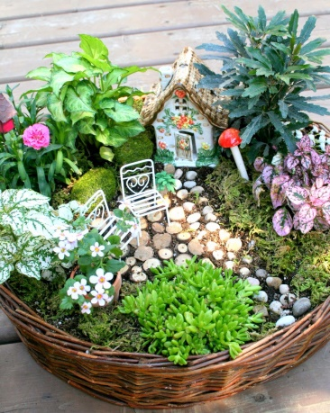
We have heard a whisper around town that there are a few fairy gardens about. We would like to invite you to create a small fairy or elves garden on a tea tray or in a container (max size 500mm x 300mm) to display in the pavilion. There will be no entry fee and therefore no prize money for these. Ribbons will be awarded.
Watch this Space!!
There will be new competition at the 2021 Show. More information to come.

Giant Pumpkin Competition
Once again, we are having the “Giant Pumpkin” competition so make sure you buy a packet of Giant Pumpkin seeds available from Springsure Newsagency – 3 seeds for $5

Friday 28th May and Saturday 29th May 2021.

Website: www.springsureshow.com
Facebook: www.facebook.com/springsureshow
President: Mrs Christine Rolfe
Show Secretary: Mrs Leanne Jones Email: spaas1865@gmail.com
Minute Secretary/ Sponsorship Coordinator: Mrs Sarah Bridgeman Email: springsureshow1865@outlook.com
Treasurer: Mrs Jaclyn King Email: spaas1865treasurer@gmail.com

