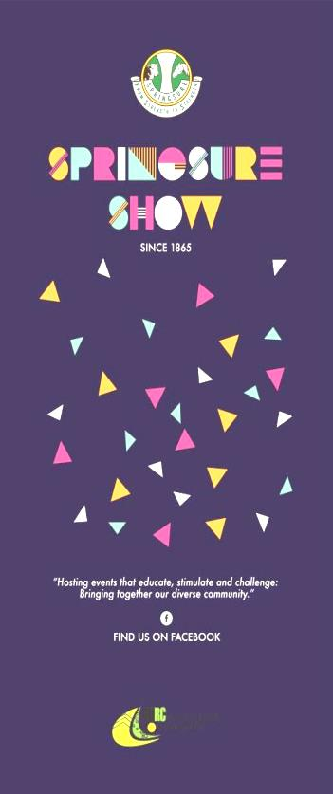
Show News – April 2021
Welcome to the April edition. This month we would like to acknowledge a FEW of the wonderful sponsors of the 2021 show. If you have sponsored our show this year and your name is not listed below, please know that your generosity is very much appreciated.
Further listings of our sponsors will be in next month’s newsletter.
- 1800 Prints  - Christmas Creek Cattle Co  - The Capricornian  - Lachlan Millar MP  - SOJITZ MDS Mining  - Glencore Rolleston Coal  - Origin  - HHH Partners  - NAPCO – Mantuan Downs  - Johnston Mechanical  - CQ Saddlery  - Medway Grazing  - Sun Valley Trading Co  - Bettafield Charolais  - BMS Laser Sat Pty Ltd  - St Brendan’s College Yeppoon | - Somerby Pastoral  - Kenna’s Chartered Accountants  - Basalt Creek  - Colinta Holdings  - Terry & Catherine Piggott  - Hillside Grazing  - A & J Simpkin  - Zahl Families  - Ross Bates  - B Wings Dot Pastoral  - Mr & Mrs G Young  - Mr & Mrs A Woolcock  - Jono & Carmel Tibbles  - Nixon Transport  - L & K Muller  - CHRC

Membership
If you would like to become a member, forms are available from our website, the Springsure Library, Rolleston Transaction Centre or by emailing the email addresses at the end of this newsletter.
Membership fees are due by 30th April 2021

2021 Schedule
The Schedule for this year is now available at some shops in Springsure.
Springsure and Rolleston Libraries will have electronic copies of our schedule – the library assistants will print off sections of the schedule you are interested in for a small fee. The schedule, as well as entry forms will also be available on the website.

For up to date information on the show check out our website and Facebook page.

Website: www.springsureshow.com
Facebook: www.facebook.com/springsureshow

